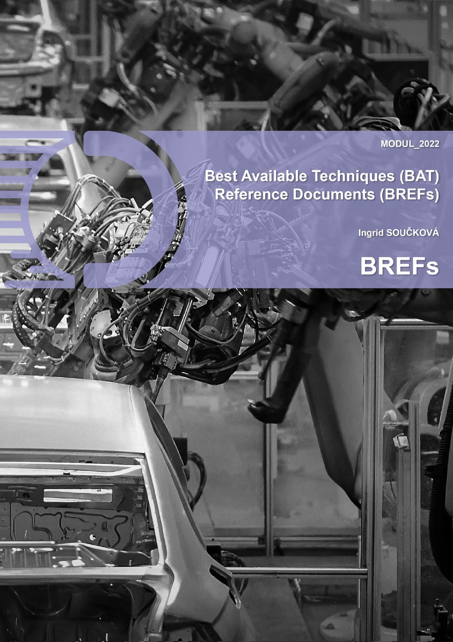

This publication is a result of a project funded by the European Union's Erasmus+ program.

© [2022] [Ingrid SOUČKOVÁ]

This work is licensed under the Erasmus+ Open Access. You are free to:

- Share: Copy and redistribute the material in any medium or format.

- Adapt: Remix, transform, and build upon the material for any purpose, even commercially.

Under the following terms:

- Attribution: You must give appropriate credit, provide a link to the license, and indicate if changes were made. You may do so in any reasonable manner, but not in any way that suggests the licensor endorses you or your use.

- No additional restrictions: You may not apply legal terms or technological measures that legally restrict others from doing anything the license permits.

For more information about the OPEN LICENSE, please visit Erasmus+ Open Access [link - <https://erasmus-plus.ec.europa.eu/programme-guide/part-a/important-characteristics-of-the-erasmus-programme>].

By using this work, you acknowledge and agree to the terms of the [Erasmus+ Open Access]. You are not required to seek permission from the author or copyright owner for using this work under the conditions specified in the license.

Thank you for respecting the principles of open licensing and promoting open access to knowledge.

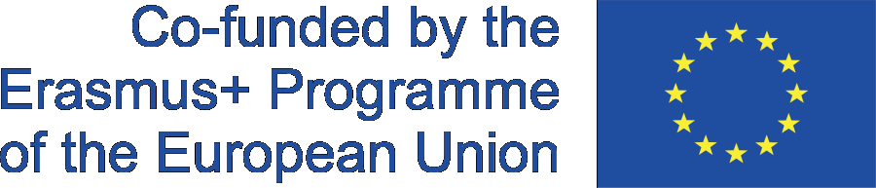



Table of contents

1. INTRODUCTION 1

2. WHAT IS A BREF AND WHAT IS ITS AIM 3

3. IMPORTANCE OF BREF DOCUMENTS 5

4. THE GENERAL BREF FORMAT 7

5. “HORIZONTAL” AND “VERTICAL” BREFs 9

6. PROCEDURE FOR THE DRAWING UP AND REVIEWING OF BREFs 11

6.1. General procedure for the drawing up of a new BREF 11

6.2. General procedure for the review of a BREF 11

6.3. Workflow for the drawing up and reviewing of BREFs 12

7. DEFINITION OF BEST AVAILABLE TECHNIQUES, BATs 14

8. BAT REFERENCE DOCUMENTS (BREFs) AND GUIDANCE MATERIAL 16

9. ACHIEVED ENVIRONMENTAL BENEFITS 20

10. ORGANISATION OF THE EXCHANGE OF INFORMATION 30

10.1 The role of the Committee 30

10.2 The role of the Forum 30

10.3 The role of the technical working groups (TWGs) 30

10.4 The role of the EIPPCB 31

11. QUALITY ASSURANCE OF THE DRAWING UP AND REVIEWING OF THE BREFs 33

12. CONCLUSIONS 35

13. TEST QUESTIONS 37

14. REFERENCES 38

# INTRODUCTION

"Reducing industrial emissions has been a main objective of every sector in recent years. Production processes are being constantly improved, the transition to a resource-efficient, low-carbon circular economy is being encouraged, and the lessons learned are being shared with others. The European Commission acknowledges the continuous improvement of the environmental industry performance through BREF process under the Industrial Emissions Directive”[1].

According to the UNEP source: “The world is currently warming faster than at any other time in recorded history. If this heating continues, the consequences will have a devastating impact on the planet, setting off starvation, flooding coastal homes, along with more fires, droughts and hurricanes. Nevertheless, the worst of these effects can be avoided. In order to achieve this, we need to limit the exponential increase in temperatures to an average 1.5°C above the pre-industrial levels. The human-caused warming has reached the 1°C mark around 2017. The world must reduce greenhouse gas emissions by 30 Gigatonnes per year by 2030 to ensure a secure future below 1.5°C. Industry and transport are not enough. We must reduce carbon emissions by managing resources and land more efficiently, including reducing deforestation and food waste and building smart cities. It is imperative that greenhouse gas emissions fall, as the impacts of climate change are increasing all around the world. Because of the climate crisis, a rapid society transformation is required. Action is vital in transport, industry, building sectors and electricity supply, as well as in food and financial systems, since limiting global warming to just 1.5°C is proving unattainable. Current policies even point to a temperature increase of 2.8°C by the end of the century, research shows.” [2, 3]

“BREFs latest version of the BAT (Best Available Techniques) reference document which is published by the European Commission is produced through a highly participative information exchange process managed by the European Commission. This exchange process involves the European Integrated Pollution Prevention and Control Bureau (EIPPCB) chair, the Commission, Member States, environmental non-governmental organisation (NGO) and the industries concerned, as shown in Fig. 1, and is hereafter referred to as the BREF process.” [4]

“An early step in the process is the environmental aspects agreement by the Technical Working Group (TWG) that forms the focus of the BREF. These aspects are known as the Key Environmental Issues (KEIs). This decision is navigated by suggestions from TWG members and other data which they provide in support. Numerous factors are taken into consideration by the TWG to arrive at a decision. These include factors such as data availability, impact significance and contribution of the sector to overall impacts.



“The BREF production process involves information gathering on the installations and techniques performance in terms of short- and long-term emissions, consumption of water, energy and raw materials and the generation of waste. It then assesses the monitoring, the used techniques, cross media effects and their technical and economic viability and developments. The process then results in the identification of the best available and emerging techniques and their associated level performance. The resulting BREF describes applied techniques, defined activities, emission and consumption levels, techniques considered for the determination of BAT, as well as BAT conclusions and any emerging techniques.”[4, 5]

“BREF users are mainly operators of installations, environmental Authorities (Permit writers, Policy makers) and the public in general.”” [15]

At the outset, it is necessary to write that this text contains standards, directives, normative documents and legislation, and defined measures of the European Parliament and of the Council on industrial emissions, therefore we present them in full, from the sources mentioned.

# WHAT IS A BREF AND WHAT IS ITS AIM

“A BREF is a technical document which presents factual, technical and economic information, reflects the information exchange outcome under Article 13 of Directive 2010/75/EU and contains necessary elements which lead to the BAT conclusions for the concerned activities” [5]. As stated in the BAT REFERENCE DOCUMENTS – BREF document, the reference document is drawn up considering the following criteria:

“1. Use of low-waste technology

2. Use of less dangerous substances

3. Recovery and recycling promotion of the substances generated or used in the technological processes where appropriate and the recovery and recycling of waste, where appropriate

4. Devices, operating methods and comparable processes which have already been tested successfully on an industrial scale

5. Technical and scientific knowledge development and their interpretation

6. Nature, effects and relevant emissions quantity

7. Dates of putting existing or new equipment into operation

8. The required time for the best available technique implementation

9. Consumption and type of raw materials (including water) used in energy efficiency and technological process

10. The requirement to prevent or reduce to a minimum the overall effects of emissions and the resulting risks which they present to the environment

11. The requirement to prevent accidents and minimise these consequences on the environment

12. Status and development information of the best available techniques and their monitoring, published by the European Commission or international organisations.” [6]

“The purpose of the Reference Document on Best Available Techniques (BREF) is to recognize Best Available Techniques (BAT) and to decrease the imbalance in the level of emissions from industrial activities in the European Union. The BREFs aspires to provide information to the Commission, Member States´ competent authorities, industrial plant operators and the general public on BAT and techniques emerging for activities covered by Directive 2010/75/ EU of the European Parliament and of the Council on industrial emissions. (IED Industrial Emissions Directive).

BREFs are prepared by the so-called technical working groups (TWG, Technical Working Groups) in the European Union, as materials for the application preparation for an integrated permit. The BREF creation is ensured by the IPKZ European Office (European IPPC Bureau) which resides in Seville (Spain). The final responsibility for the BREF publication lies with the European Commission.” [5]

“”The EIPPCB (The European Integrated Pollution Prevention and Control Bureau) - is defined as a project which is known within the fifth framework program of the European Commission to complete the technical work in the Commission Services, in particular of DGs Environment and Enterprise. Moreover, it is also an exceptional group of experts, recruited to work on the EIPPCB project. Their individual expertise on environmental permitting and process engineering supplement their specific expertise on one or multiple subject work areas. This has created a multi-national team of people who are dedicated to producing quality reference documents, in order to assist the efficient and effective IPPC Directive implementation. The EIPPCB is not least a focal node for all relevant information and knowledge to be discussed with other renowned experts at a technical level. The EIPPCB is a part of the Circular Economy and Industrial Leadership Unit of Directorate B - Growth and Innovation which is one of six scientific directorates of the European Commission's Joint Research Centre.” [14, 15]

“Efforts have also been made to urge technology suppliers to partake in the work of the TWGs, since they are key to technology innovation and development. Involvement in TWGs is limited to EU level organisations and ESWET (European Suppliers of Waste-to-Energy Technology) and EPPSA (European Power Plants Suppliers Association) which have been present for a long time. As of late, ACCESSA (Association for Catalytic Control of Emissions from Stationary Sources) has met that requirement and now participates in the TWGs.” [4]

“A series of elements at the core of each BREF is leading to the determination of what can be perceived as the best available techniques (BAT) based on prior information and the relevant emission limits for the sector. At the end, the BREF holds information about the techniques which are being developed in the given industry.

BREFs – including emission limits – are not legally binding, however, they provide the most up-to-date data on best available techniques. When issuing an integrated permit, these must be taken into account. Likewise, they indicate the state of the art that the industry has accomplished. The industry thus makes it possible to create new standards in the area of BAT with its innovations, and therefore also derive emission limits. When deciding on emission limits in individual cases though, local conditions must be considered. In EurEau (2021) it is written: “If anyone is interested in partaking in the preparation of the BREF, they can contact the European IPPC Bureau: <http://eippcb.jrc.es>”.

“Developing the BREFs and updating the provided information is a long and challenging job to offer the right level of information and to accomplish the performance required of the proposed techniques in their implementation. Multiple stakeholders are involved and it can lead to complex discussions. The final document approval may take more than a year of negotiations. The official BREFs updating cycle is eight years, however, it generally takes more time because of the work needed for the development and the arduous negotiations which precede their final adoption. BREFs are not a fast and reactive instrument.” [5]

# IMPORTANCE OF BREF DOCUMENTS

“The purpose of a BREF is to offer information to the Commission, competent authorities of Member States, Industrial operators and the public at large to guide the determination of BAT-based permit conditions or general rules by providing relevant information to the permitting of installations according to the IPPC Directive 96/61/EC. A BREF should serve towards improving the environmental performance throughout the European Union.

Directive 2010/75/EC on industrial emissions the IED is the successor of the IPPC - the first set of BREF 2002-2008 was non-binding. It was implemented on November 24, 2010, and it is basically about minimizing pollution from a variety of industrial sources across the EU.

Industrial facilities operators that operate activities covered by Annex I of the IED are required to attain an integrated permit from authorities in the EU countries. The directive covers approximately 50.000 installations throughout Europe (for example Chemicals, Glass, Power Plants, Cement, Animal husbandry, Refineries, Automotive/Metal industry, Waste treatment/incineration and so on. The goal is to create a “level playing field” in all EU countries. The Directive defines BATs (Best Available Techniques) and BAT-AELs (Associated emission levels), compiled in 33 BREFs (BAT Reference Documents). Across Europe BAT/BAT-AELs are the basis of permits. AELs are binding, BAT is “neither prescriptive nor exhaustive”. The BREF consists of 500-1000 pages with the process taking approximately 3-8 years.” [7]

“The IED covers some new activities, this could mean that the number of installations will slightly increase. Most of the major industrial producers in Europe are affected by the IED. A BREF is a complex, multi-step, technical process which involves all parties, as shown in Figure 2.” [7]

As reported by the industrial emissions Directive, “it is imperative to be active in the BREF creation because:

• BAT-AEL in BAT conclusions will be binding for permits: emission limit values in permits cannot be higher than BAT-AEL, derogations are very hard to justify under IED, and you cannot fix at permit level what went wrong at BREF level.

• BREF process continues, with or without company/society input if the company/society:

* does not classify itself timely in the process, it will not be efficient to provide high-quality inputs in short deadlines,
* does not meet the shutter, it does not get a second option,
* doesn't give the data, someone else maybe will,
* does not attend Technical Working Group (TWG) meetings, the position will not be recorded (despite any previous written accession).

• And most importantly, BREF is a technical process, which depend on knowledge and expertise”. [8]

“Industry is responsible for a significant share of overall environmental impacts. The IED is the main legislation of the EU which regulates the environmental impacts of large agro-industrial sources. It combines and strengthens previously set requirements under seven different EU Directives, namely” [8]:

1. The Integrated Pollution Prevention and Control Directive (IPPCD)[1]
2. The Large Combustion Plants Directive (LCPD)[2]
3. The Waste Incineration Directive (WID)[3]
4. The Solvent Emissions Directive (SED)[4]
5. Council Directive 78/176/EEC on waste from the titanium dioxide industry[5]
6. Council Directive 82/883/EEC on procedures for the surveillance and monitoring of environments concerned by waste from the titanium dioxide industry[6]
7. Council Directive 92/112/EEC on procedures for harmonizing the programs for the reduction and eventual elimination of pollution caused by waste from the titanium dioxide industry[7].

# THE GENERAL BREF FORMAT

“The first BREFs, established under Directive 2008/1/EC that codified rules for permitting industrial installations were laid out by the Integrated Pollution Prevention and Control (IPPC) Directive 96/61/EC. Later, the IPPC Directive was repealed by the Industrial Emissions Directive (IED) 2010/75/EU” [9, 10].

Each BREF should adhere a standard format. Understanding of the methodology and approach applied in the substantive chapters is essential for correct interpretation of their content. Both UNIDO and the European Commission state that “BREFs are structured as follows:

* ***“Preface, scope and general information*** - it can be read and understood as a “stand- alone” document.
* ***Specific information about the sector*** – there is general information refers to a precise, correct descriptions of basic facts about the sector.
* ***Applied processes and techniques*** - contains general descriptions of production processes and techniques applied intended for the benefit of non-specialist in the particular sector. In particular, it includes - raw “”materials used, consumables and energies, product manufacture and product finishing, product storage and handling.
* ***Current emission and consumption levels*** - reports on emission and consumption levels of energy, water and raw materials, issues such as noise or odour, emissions of solid residues, options for recycling and re-use of output streams. These data may be compared to relevant standards set in national or international legislation.
* ***Techniques to consider in the determination of BAT*** - provides a catalogue of emission reduction or other environmentally beneficial techniques. Identifies environmental benefits, indicates possible cross-media effects together with the costs of implementation, practical applicability, technical problems and the overall economic impact. Techniques presented may apply to the improvement of installations. Information on each technique should preferably include the following elements - brief technical description with pictures, diagrams and flow sheets, main achieved environmental benefits, operational data (actual performance), cross-media potential effects due to implementing the technique, applicability, economic information, specific conditions, legislation, increased yield, product quality improvement, references to literature and example plants in operation be it in Europe or world-wide.
* ***Best Available Techniques, BATs*** - it does not set emission limit values but rather suggest emission and/or consumption levels that are associated with the use of BAT and explain the basis for the conclusions.
* ***Emerging techniques*** - identifies any novel pollution prevention and control techniques under development that might bring some cost and/or environmental benefits, indicates the potential efficiency of the technique, a preliminary cost estimate and the time needed to have it commercially “available“, warn about possible environmental issues.
* ***Concluding remarks and recommendations for future work***
* ***References***
* ***Glossary of terms and abbreviations***
* ***Annexes*** (depending on sector and availability of information).” [9, 10]

# “HORIZONTAL” AND “VERTICAL” BREFs

BAT reference documents (BREFs) introduce the result of the “Sevilla Process”. Most BREFs coverlet specific agro-industrial activities; these BREFs are referred to as “sectoral BREFs”. Nevertheless, numerous “horizontal BREFs” are dealing with cross-cutting problems such as industrial cooling systems, energy efficiency or emissions from storage with importance for industrial manufacturing in general. A "ROM" (Results Oriented Monitoring) has been developed as a specific BREF document for monitoring air and water emissions from installations, under the Industrial Emissions Directive [10].

“According to the Commission Executive Decision of February 10, 2012, laying down rules on guidelines for data collection, the preparation of BAT reference documents and the quality assurance pursuant to Directive 2010/75/EU of the European Parliament and of the Council on industrial emissions (notified under document C (2012) 613) the Horizontal and Vertical BREF are designed as follows - BREFs may be limited either to issues associated to specific industrial activities - vertical BREFs, or may tackle cross-sectoral issues - horizontal BREFs.” [10, 11]

“A total of 33 BREF documents comprises of “vertical” sector specific BREFs concentrating on one or more of the industrial activities listed in annex to the IPPC Directive and “horizontal” subject BREFs addressing IPPC issues throughout industry sectors (i.e., common wastewater and waste gas systems, storage, energy efficiency and cooling systems). There are also two horizontal documents, not containing BAT conclusions, called REFs, i.e., monitoring, and economics and cross-media effects reference documents. These horizontal (B)REFs do not stem from activities named in Annex 1 but from the general approach of IPPC within the Directive itself. Seven existing Directives related to industrial emissions were altered into a single document in December 2007, subsequently (re)codified as Directive 2008/1/EC. However, the substance of Directive 96/61/EC has not been modified.” [12, 13, 35]

“The BREFs full sets make up an information matrix in order to reduce the quantity of duplication between them. In this meaning, it is crucial to understand the distinctions between horizontal and vertical BREFs and how they may complement one another. A “vertical” BREF takes preference over a “horizontal" BREF because the information exchange has allowed the sector specificities. In question to be considered. When a relevant environmental issue is not specifically dealt with/addressed in a “vertical” BREF, the relevant „horizontal” BREF(s) applies. The same principle is valid in the BAT sections.

Since the “vertical” BREFs aim to minimise the information duplication with other reference documents, usually do not repeat „horizontal BAT “.Preventing repetition results in smaller BREF documents which is strongly advocated by end-users.” [12, 13, 35]

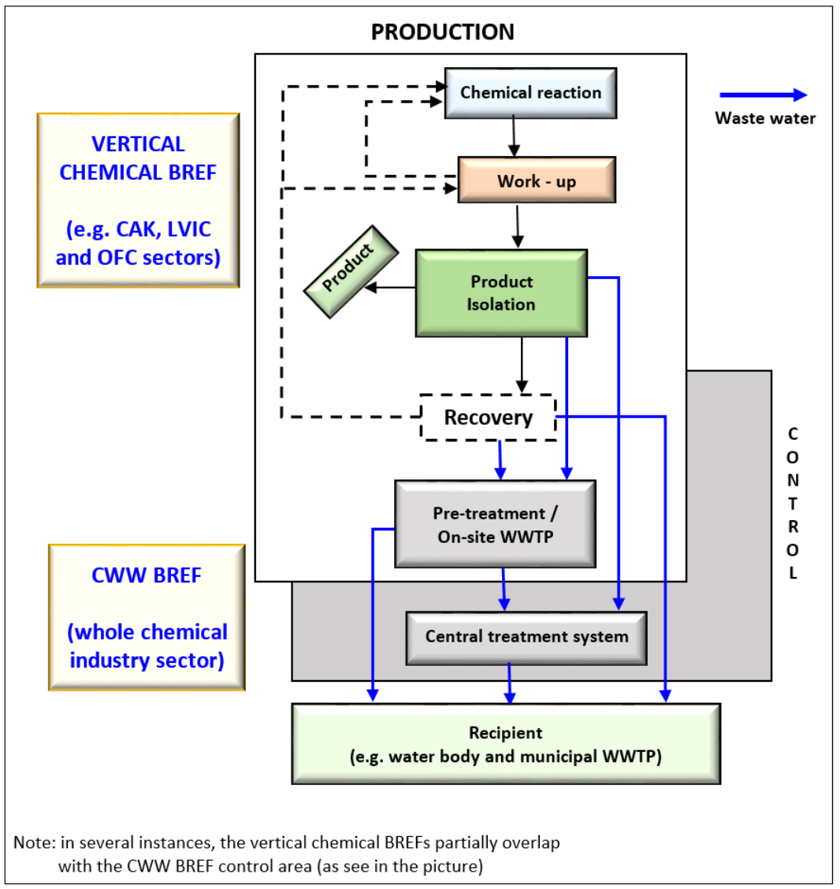

*Explanatory notes:*

*WWTP – Waste Water Treatment Plant, CAK - Production of Chlor-Alkali, CWW - Common Waste Water and Waste, LVIC - Large Volume Inorganic Chemicals, WGC - Waste Gas Treatment in the Chemical Sector, OFC - Other Fine Chemicals, Gas Treatment*

“One of the first chemical BREFs to be developed was the CWW BREF. Its scope covers the entire chemical sector. It has been much referenced and used in the making of a in a number of other chemical BREFs. Since some of the techniques which are described in the CWW BREF are used in other sectors than the chemical industry, the CWW BREF is also referenced in a numerous non-chemical BREF documents, e.g. Ceramic Manufacturing Industry, Cement and Lime Manufacturing Industries, Surface Treatment using Organic Solvents, Surface Treatment of Metals and Plastics and , Food, Drink and Milk Industries BREFs. Figure 3 illustrates the boundary between vertical and horizontal chemical BREFs using the wastewater treatment as an example.” [12, 13, 35]

# PROCEDURE FOR THE DRAWING UP AND REVIEWING OF BREFs

A typical workflow for drafting and reviewing BREFs contains an initial meeting, one or two formal draft BREFs, and a final TWG meeting as major milestones, according to the Commission Implementing Decision as well as the European IPPC Bureau. [16, 17]

## General procedure for the drawing up of a new BREF

“!It was necessary to develop a new BREFs need to be drawn up, because some activities which were not include in Annex I to Directive 2008/1/EC of the European Parliament and of the Council included in Annex I to Directive 2010/75/EU (4). Newly drafted BREFs needed the collection of more information. Also, two formal drafts of the BREF are usually expected before holding the final TWG meeting. In a BREF review case, at the time of the reactivation of a TWG, Forum members are requested to nominate their TWG representative(s). These nominated TWG members are asked to provide a list of “wishes”, which will be used to prepare and structure the kick-off meeting discussions. The main issues to be debated at the kick-off meeting and proposals from the EIPPCB (The European Integrated Pollution Prevention and Control Bureau) will be defined in a background paper which is to be distributed to the TWG no less than four weeks in advance of the meeting. The most relevant new information which requires to be identified, collected and presented in the framework of the information exchange for a BREF review is that which might result in a revised or updated BAT conclusions. Moreover, the review of a BREF should contain:

1. Supplementing and updating old fundamental information which is based on new data

2. Deleting outdated and obsolete information

3. Correcting errors and eliminating inconsistencies with other BREF documents.

The BREF review will focus mainly on the BREF chapters entitled “Techniques to consider in the determination of BAT”, “Best available techniques (BAT) conclusions” and “Emerging techniques”. To a lesser degree, it will focus on the BREF chapters entitled “Applied processes and techniques” (in case of important changes in this chapter) and “Current emission and consumption levels”. A lower priority should be given to the review of the other BREF chapters. Overall, it is necessary to ensure that all the information remains in the BREF is consistent, up-to-date and achievable.” [16, 17]

## 6.2. General procedure for the review of a BREF

“To consider changes and their consequences for BAT, BREFs must be reviewed routinely and, where necessary they need to be updated accordingly. The resolution to reviewing the BREF should consider the information in the BREF chapter entitled "New Techniques" and the BREF section entitled "Concluding Remarks and Recommendations for Future Work". This should be revised together with additional factors such as the need to extend the scope of the BREF, an indication that new techniques may be available, and the need to incorporate products/substances or processes not covered yet.” [16, 17]

## 6.3. Workflow for the drawing up and reviewing of BREFs

“The Commission Implementing Decision as well as the European IPPC Bureau indicate that the timing of the work for each BREF and the exact steps will depend on various factors including the scope of the BREF (and the potential scope addition in the case of BREF reviews), the complexity and number of topics which need to be dealt with, the resources of the EIPPCB (given its central role in the process of information exchange) and, above all, the level of effective and effective participation of the TWG. The flexibility to adapt the workflow to the specifics of a particular BREF is applicable without prejudice to the overall objective to conclude the work within the time limits. Depending on the process type (reviewing or drawing up of a BREF), the following variants of the workflow are in place:

1. For a new BREF, or a revival of a BREF with a major expansion of scope, two formal proposals are usually considered necessary; the total process in such cases should take between 31 and 39 months.
2. For the first BREF review without a major expansion of a scope, two formal proposals might be necessary, though generally one formal proposal of the BREF is expected to be sufficient; and hence the process will usually take between 24 and 29 months (in the case of one formal proposal) or between 29 and 39 months (in the case of two formal proposals).
3. For subsequent BREF reviews without a major scope expansion, one formal draft is anticipated, and the process should take between 24 and 29 months.

For the TWGs, these workflow variants are reference points. After consultation of the TWG according to the specifications of a particular BREF, they can be adapted by the EIPPCB. In addition, must be taken into account experience from the drawing up and reviewing of other BREFs. These steps consider the objective set out in recital 13 of Directive 2010/75/EU that BREFs ought to be updated no later than eight years after the publication of the previous version. [16, 17]



# DEFINITION OF BEST AVAILABLE TECHNIQUES, BATs

Best Available Techniques and Emerging Techniques

Author James (2010) defines Best Available Techniques as follows: "The best available technique is the most efficient and advanced state of development of activities, technologies and the way of their operation, which demonstrates the practical suitability of a certain technique, especially from the point of view of determining emission limits monitoring the prevention of emissions in operation and other conditions of the integrated permit determined with the aim of prevention, and if this is not possible, at least the reduction of emissions and impact on the environment, while according to [18]:

1. “Technique is the technology used in the operation, the manner in which the operations are planned, constructed, managed, maintained and operated, and how the activity in them is finished.

*“Techniques” include the technology used and the way in which the equipment is designed, built, managed, maintained, operated and decommissioned.*

1. Available technology is technology developed to such a degree which allows its use in the pertinent industry under technically and economically workable conditions, considering the ratio of costs and benefits, regardless of where said technology uses or fabricates, as long as it is available to the person, who operates equipment or machine under reasonable conditions.

*“Available” techniques mean those developed on a range with allows realization in the relative industrial sector, under technically and economically viable conditions, taking into consideration the costs and advantages, whether or not the techniques are used or produced inside the Member State in question, as long as they are reasonably accessible to the service person or operator.*

1. The best technique is the most effective method for reaching a typically high level of protection of the environment as a complex.

*“Best” means the most effective achieving a high universal degree of protection of the environment as a whole.”*

The definition of the best available techniques - BAT further formulates [18]:

* Integrated approach – water, land, air. This is a new view of solutions, which is based on their mutual interconnection and logical independence.
* Guidance provided by BREF documents
* Tool for local exceptions
* Public interest
* Regular updates.

**Practical definition of Best Available Techniques (methodology)**

1. Set the scope and identify the alternative techniques under consideration

* See the BREF documents
* Relevant factors specific to the location, e.g. height above equipment
* Technics not covered by BREF

1. Prepare the emissions register and sources use, for each choice

* Important emissions/use of resources
* Changes within the type of emissions
* Bioaccumulation, Synergistic effects

1. Estimation of effects on the environment

* Can be weighted to reflect proximity to an environmental standard

1. Identify the technique that proposals the highest level of environmental protection as a whole

* The same weight to all sources?
* Long terms vs short term impacts
* Ozone as a global warming potential
* Impact on waste or resource use
* Odour, vibration and noise, etc.

1. Define the costs for individual alternative technique

* What does it contain and on what basis?
* Economic assumptions, e.g. amortisation period

1. Evaluate all possible alternatives

* Based on what parameters (e.g. point of more rapidly increasing costs, reference costs for 1 kg of polluting substance…)? [18]

# BAT REFERENCE DOCUMENTS (BREFs) AND GUIDANCE MATERIAL

“The reference document on BAT is the result of an exchange carried out in accordance with Art. 13 of the IED. It is developed in such a way that to define of activities, the current emissions level and consumption, and particularly describes the application of the technique "BAT". Currently, the IPKZ European Office has approved 33 BREF documents for the undermentioned industries:

*“Pulp and paper production, Iron and steel production, Cement and lime production, Refrigeration systems, Chlorine and alkali production, Ferrous metal processing, Non-ferrous metal processing metals, Glass production, Leather processing, Mineral oil and gas refineries, Large-scale production of organic chemicals, Waste water and waste gas management in the chemical industry, Textile processing, Monitoring systems, Intensive pig and poultry farming, Slaughterhouses and facilities for disposal or recovery of animals and animal waste, Forges and foundries”.*

The list of other industries, as well as the status of BREF processing status, can be found in the European IPKZ Office - EIPPCB (European IPPC Bureau) [18]:

“The table below (Tab.1) outlines the Best Available Techniques Reference Documents (BREFs) and advisory material from different judicatures corresponding industrial sectors, as publicized by the European Commission. Similarly OECD published "The Better policies for better lives" (2022), List of Best Available Techniques Reference Documents by activities and sectors which are covered by each jurisdiction [19, 22]. It should be noted that all sectors may be defined and classified a little differently across countries. For the purposes of this publication, we only list the BREF for the European Union in the table. BREFs for other countries, as the Russian Federation: BREFs, Korea: BRIEF, All US, NESHAP, HSPS and Industrial Effluent Guidelines, People's Republic of China: Guidelines on Available Technologies for Pollution Prevention and Control (GATPPCs), India: Comprehensive Industry Documents (COINDs) can be found on the website:” [*https://www.oecd.org/chemicalsafety/risk-management/best-available-techniques-reference-documents-by-sectors-and-activities.htm#Disclaimer*](https://www.oecd.org/chemicalsafety/risk-management/best-available-techniques-reference-documents-by-sectors-and-activities.htm#Disclaimer)“[19, 22]

Tab. 1 List of BAT BREF documents by sectors and activities covered by each jurisdiction [19, 22]

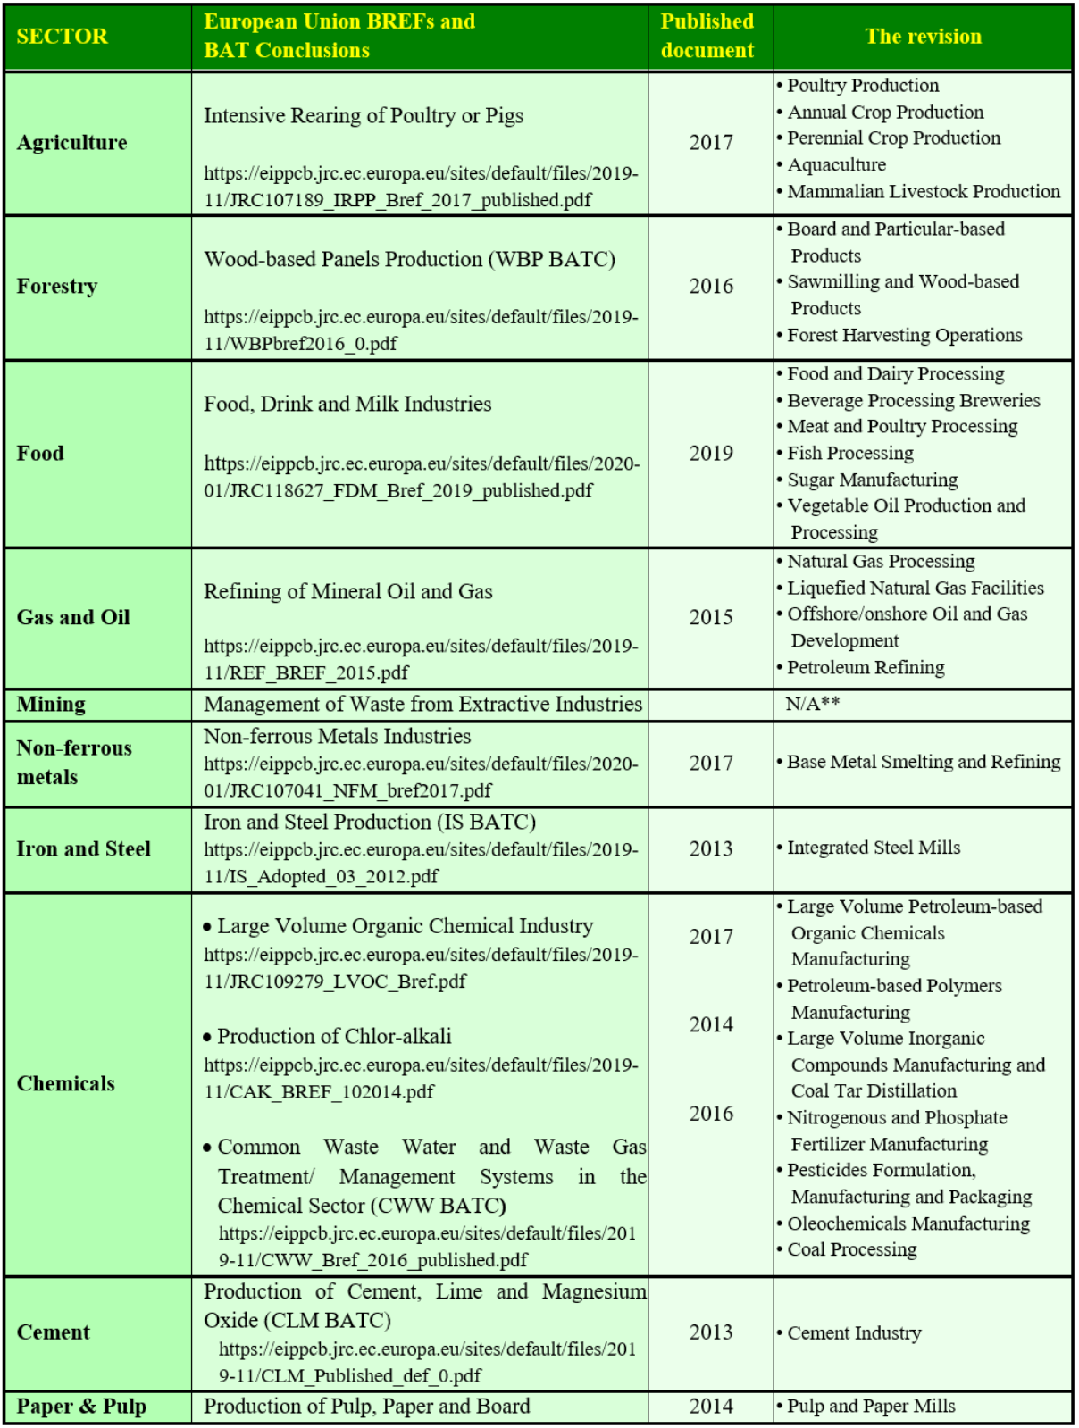

Tab. 1 List of BAT BREF documents by sectors and activities, continue [19, 22]

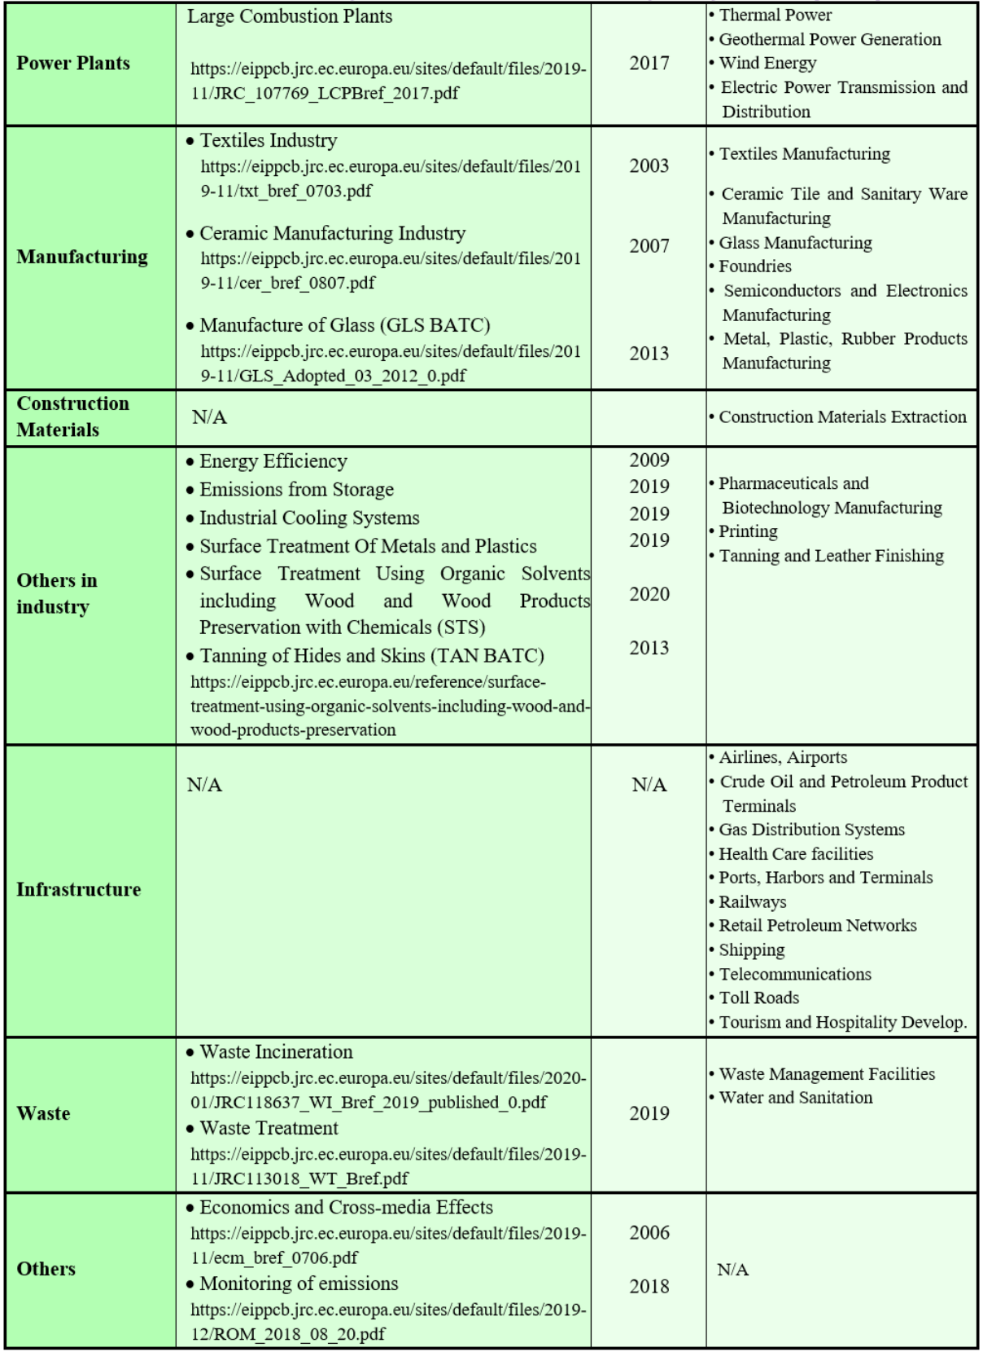

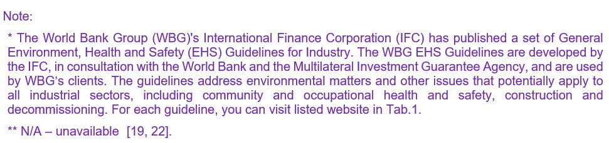

BREFs are only guidance documents. They do not have a legal status, their use is to guide Member States, industry, and the public on feasible emissions and consumption when using specified BAT techniques. When determining emission limits and other conditions, local conditions are always taken into account. The emission limit values may be lower or higher in specific cases. Air quality and environmental water standards may mean more stringent values – or possibly zero emissions/discharges. There may be cases where the emission limit values might be less stringent - aligned with the “best for the environment as a whole” principle, as it is stated by the source. [15]

# ACHIEVED ENVIRONMENTAL BENEFITS

“It is essential to provide actual performance data of a particular device in accordance with the conditions which are set by the laws on economic competition and the protection of confidential business information (including, concentration and specific load of pollutants (if available), emission levels or the data required to derive this information. This includes the methods used when monitoring and the reference conditions. For specific load data, the product referred to should be defined clearly, the consumption level - water, energy, raw materials - and the amount of residues/waste generated from well-functioning plants (with respect to the environment the whole) the use of the technique will be specified together with relevant contextual messages,

* How to plan, design, operate, control, maintain and decommission the equipment
* Emission monitoring issues related to the equipment use
* Durability and sensitivity of the equipment
* Issues concerning environmental accident prevention.” [24, 25]

As further published by DG ENV and the OECD: Links between inputs (e.g. character and quantity of raw material and water, energy and fuel) and outputs (products, emissions, residues/wastes) will be highlighted. Especially, where they are applicable to enhancing an understanding of different environmental impacts and their interaction. For instance, where some trade-off has been made between different outputs such that certain levels of environmental performance cannot be reached at the same time. Consumption and emission data will be qualified as far as possible with details of relevant operating conditions (e.g., fuel composition, percentage of full capacity, bypassing of the (abatement) technique, inclusion or exclusion of other than normal operating conditions, reference conditions), sampling and analytical methods, and statistical presentations (e.g., ranges and distributions, short-term and long-term averages, maxima). Information on circumstances/conditions hampering the (abatement) technique use at full capacity and/or necessitating partial or full bypassing of the (abatement) technique and measures taken in order to restore full (abatement) capacity shall be included. The reporting in this section of the BREF is crucial for deriving environmental performance levels which are associated with BAT.

This directive concerns “industrial activities causing pollution”. In this connection, BREFs outline the best available techniques for removing pollution that is being emitted by industries whose vital mission is to produce goods rather than to handle wastewater. Hence, the industry is in need of guidance to implement the minimum treatment level necessary in order to minimize their environmental impact. [24, 25]

Large industrial and agro-industrial installations are responsible for a significant share of total human environmental impacts. They can use large amounts of material, chemicals, energy and water. They can emit significant amounts of pollutants to the air, water and soil and generate substantial shares of hazardous and non-hazardous waste. These environmental impacts vary by type of activity and can be very specific to the type of installation or the processes incorporated in a given site. These rather varied impacts as well as varying local conditions where such installations are subject to a regulatory regime, generally necessitate site-specific requirements. Given the diversity of installations, establishing the environmental limits for each is challenging for regulatory officials. This can be contributed by frameworks where permits are granted at a local level and officers have no experience of dealing with multiple installations of a similar type. The application of BAT reference documents (BREFs) is a solution that has been operating in various jurisdictions around the world. The aim is to support the permit conditions setting for industrial sites. Figure 5 demonstrates how they fit in the regulatory framework. It also shows the key aspect of the overall regulatory regime which is covered by this document. This document also indicated the selection of sectors to regulate, as well as the development of permit conditions. [24, 25]

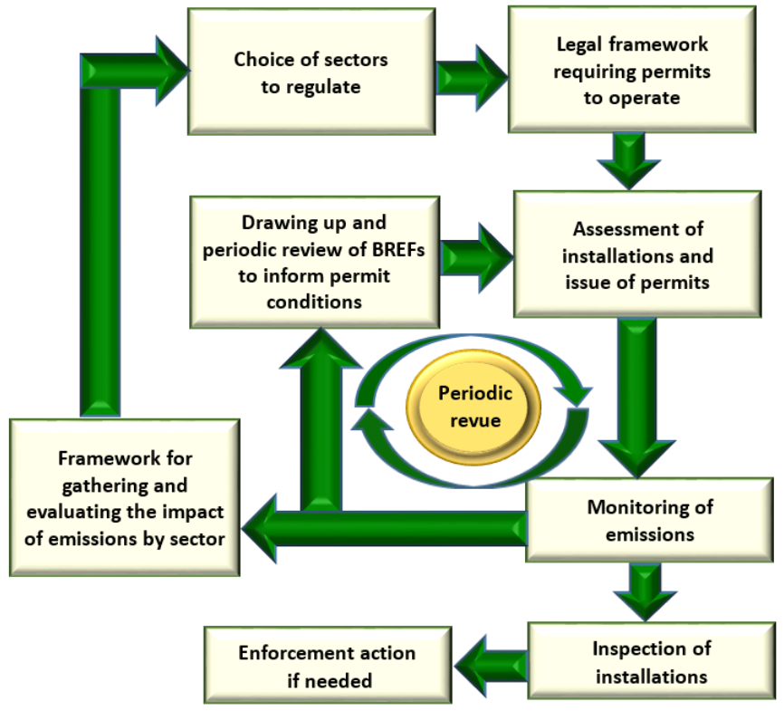



“To ensure a stable climate and adhere to the commitment of the Paris Agreement, UNEP (The United Nations Environment Programme) has identified six sectors which have the potential to reduce emissions to a level which would keep the world below the 1.5°C mark.” Which are these sectors? See a list below according to the UNEP source.

|  |
| --- |
| **The Emissions Gap Report** |

“All data has been estimated from UNEP´s flagship 2022 edition of the Emissions Gap Report. Currently, the interactive story is being updated so it reflects the reports latest data.” [26]

|  |
| --- |
| 1. **Energy** |

“In the energy sector, greenhouse gas emissions have to be reduced by 12.5 Gigatonnes (Gt) per year. The aim is to build a momentum around the shift to a decarbonized economy. To achieve this, governments must increase their contributions to the Paris Agreement. This will send a resounding signal to governments that cities, regions, business and investors are united in reaching the Paris goals and building a more inclusive, resilient economy. [27]

However, achieving the Paris Agreement temperature goal requires a swift global transformation of the power system. It is the single largest source of energy-related CO2 emissions in the world, covering 42% of total energy related emissions (International Energy Agency [IEA] 2021c).” [26]

As reported by Boehm et al. and Ayaburi et al.: “At least four shifts need to occur to decarbonize power:

1. Steeply accelerating the share of zero-carbon power,
2. Phasing out unabated coal and gas generation,
3. Adapting grid/storage and demand management - a decarbonized power system relying primarily on renewables will require different grid systems than exist today. Flexibility will be key in decentralized supply, storage and demand, given the characteristics of wind and solar.
4. Ensuring reliable energy access for all - currently, 10% of the world’s population has no access to electricity and over 40 per cent has unreliable access [28]. Ensuring universal energy access must be part of the shift to a global clean energy system.” [29]

|  |
| --- |
| 1. **Industry** |

“Industry can decrease its emissions by 7.3 Gt per year by embracing passive or renewable energy-based cooling and heating systems which improves energy efficiency and addresses other urgent issues, such as methane leaks.” [27]

The largest contributor to global emissions is the industry sector when direct and indirect emissions are included. When considering only direct emissions, it is the second-largest contributor (IPCC 2022) [30]. To date, attempts to reduce emissions have mainly aimed at improved energy efficiency and application of best technologies available. Since many industrial processes have already reached maximum theoretically attainable energy efficiency, the crucial changes needed to bring the industry sector to a Paris-compatible pathway. These include, according to the authors Teske et al.:

1. “Electrifying industry and transform production processes by using new fuels (substitution, demand reduction and carbon management are vital for decarbonizing the industrial sector), and specific solutions for hard-to-abate sectors (there is a great potential for green hydrogen to help decarbonize several sectors, especially the hard-to-abate energy-intensive industry sectors which cannot use electricity, green hydrogen production capacity needs to develop),
2. Pressuring material efficiency and scaling up energy efficiency everywhere (material processing and increasing demand are the main industrial emissions drivers, basic production of materials leads to surges in both direct and indirect emissions). Supply side interventions include the changing the material intensity of the product used,
3. Promoting circular material flow - waste materials recycling aids to reduce emissions, but the growing complexity of product design and functionality increases the materials demand. There are still vast gaps and regional discrepancies in recycling. The recycling rates across various metals differs from 20 to 85 per cent, and the recycling rate of end-of-life waste from industrial material is extremely low at cca 10%.””[31]



|  |
| --- |
| 1. **Agriculture, Food & Waste** |

“New solutions in the field of food production are able to reduce emissions by 6.7Gt a year. Reduction of food loss, food waste and switching to more sustainable diets can decrease emissions by more than 2Gt a year. Spoiled food happens from the farm to the fork and shifting to a plant-rich diet is one of the biggest steps we can do ourselves to emit less Green House Gas. Moreover, it is good for our health.”[27]

As reported by UNEP (2022): “Food systems are major climate change contributors. Other environmental problems, such as land-use change, biodiversity loss, freshwater resources depletion and pollution of aquatic and terrestrial ecosystems through nitrogen and phosphorus run-off from fertilizer and manure application. If current trends do not improve, the environmental burden on food systems are prone to intensify. Main targets of several Sustainable Development Goals (SDGs) are portrayed to be at risk and the greenhouse gas (GHG) emissions from food systems could, on their own, hinder achieving the Paris Agreement objective of limiting global warming to below 2°C, aiming for 1.5°C.” [30]

“Transformation of food systems is therefore essential for avoiding dangerous climate change levels and other environmental problems. What is more, transforming food systems is not only crucial for addressing climate change and environmental degradation, but also vital for ensuring healthy diets and food security for everyone.”[30]



|  |
| --- |
| 1. **Nature-based Solutions** |

“The world can decrease emissions by 5.9Gt per year if it halts deforestation, ecosystem degradation and re-establishes ecosystems. These measures would also, bolster water security, improve air quality and shore up rural economies. Above all, investments in land, freshwater and marine ecosystems can make a significant contribution to increasing climate resilience.”

**As reported by UNEP (2020): "Potential solutions and actions required at all level:**

* Impose and strengthen energy efficiency standards,
* Promote the use of efficient and renewable heating and cooling,
* Incentivize and mandate less emissions of greenhouse gases, including cutting methane leaks,
* Scale up research and development to create new options for low-carbon industrial processes,
* Audit the energy use and resource efficiency of your operations to identify cost-effective high-impact reductions,
* Take precautions to climate risk,
* Embrace the opportunities associated with renewable energy and resource efficiency,
* Be a leader in sustainable industrial practices,
* Advocate for clean energy in your organization,
* Reduce, reuse, repair and recycle what we consume,
* Support companies that practice sustainable and circular practices; for example, patronize businesses that provide spare parts, offer take-back services to reclaim used goods and use recycled materials.
* Halve tropical deforestation by 2025 and stop net deforestation by 2030 globally
* Call for the protection and revival of ecosystems all around the world, for the benefit of people and nature, as the last chance to prevent catastrophic climate change.
* Systematically monitor and evaluate the progress of conservation and restoration efforts
* Work with suppliers to find collaborative solutions to minimize ecosystem impacts across the supply chain
* Invest in landscape conservation and restoration as part of net-zero emission efforts; investments must meet high social and environmental standards
* Adopt a diet that reduces forest habitat loss, peatlands drainage and degradation by shopping locally and in season.
* Whenever possible, neutralize your carbon footprint through investments in natural carbon sinks, such as forests and peatlands.
* Work with suppliers to find collaborative solutions to minimize ecosystem impacts across the deforestation-free supply chain
* Invest in landscape conservation and restoration as part of net-zero emission efforts; investments must meet high social and environmental standards.” [27]

|  |
| --- |
| 1. **Transport** |

Transport is accountable for about one-quarter of all greenhouse gas emissions, set to double it by 2050. That number can be reduced with up to 4.7Gt by using electric vehicles in private and public transport and urging people to walk, cycle and use non-motorized transport by creating safe spaces. If we do not decrease vehicle emissions, deaths from exhaust fumes in cities will increase exponentially by more than 50% by 2030.”[27]

As UNEP (2020) states: Several changes are required to transform the transport system:

1. In addition to the electrification of transport modes, a transition to low-emission modes of transport, including public transport, cycling and walking is needed to align with temperatures well below 2°C and 1.5°C.

2. It is essential to accelerate the transition to cars and trucks with zero carbon emissions. Heavier vehicles, including buses, medium-duty and heavy-duty vehicles (MHDVs), should also be decarbonized.

3. It is necessary to prepare for the transition to zero carbon aviation and shipping. In addition, car and plane use by frequent travellers should be reduced. These changes should be supported simultaneously, and many actions can address more than one change. [27]

|  |
| --- |
| 1. **Buildings and Cities** |

“Buildings will account for about 12.6Gt of energy-related emissions by 2030. But 70% of the urban infrastructure needed to adapt to a rapidly growing world has not yet been built. By adapting the cities and homes of tomorrow for a low-carbon age - and by renovating/updating existing infrastructure - we can reduce emissions by 5.9Gt. [27]

Direct emissions through building operations are rather small in comparison to other sectors, estimated at 5% of global greenhouse gas emissions. However, this number rises to 17% when accounting for indirect emissions from electricity and heat consumption (IPCC 2022).” [30]

The Emissions Gap Report 2022 published the following: Four main changes are needed to reduce emissions in the building sector:

1. It is necessary to minimize the excess floor area. Energy consumption and emissions from water and space heating and cooling are directly linked to the total portion of floor area that is subject to active thermal regulation. Furthermore, the greater the extent of new floor space that is built, the more materials are required, and the higher the emissions involved. Minimizing the size of the floor area, which is significantly higher than the area needed to meet basic needs, can have a large impact on emissions in the sector.

2. It is necessary to reduce energy consumption. The energy that is used for appliances, cooling and heating per square metre of floor area, needs to decrease globally by 20–30% in residential buildings and 10–30% in commercial buildings by 2030.

3. The emissions intensity of energy consumption must decrease. In buildings, this means installing and replacing heating and cooking equipment with cleaner technologies. Instead of heating with gas or oil, or district heating in dense urban areas, to use devices such as heat pumps.

4. It is necessary to take measures to reduce the emissions intensity of materials by using them more efficiently, by rebuilding existing objects (rather than demolition and new construction), substituting alternative construction materials, minimizing their volume and minimize energy demand throughout the building construction phase, including transport and on-site energy use. Also furnishing the interior of buildings can be energy-intensive. Circular economy principles provide opportunities for lifecycle emission reductions. [30]

“Subsidies throughout all sectors should be reallocated from supporting high-emitting processes and behaviour to advocating for sustainable low-carbon alternatives - or at the least, a level playing field.

The United Nations Environment Programme works throughout these six sectors to support the transition to a low-carbon, more resilient future where we decrease emissions emitting and ensure the six sectors can also adjust to the climate impacts that are anticipated. We enable science-based decision-making, capacity support and institutional strengthening and provide guidance and tools on financial and legal frameworks that facilitate climate-smart development. The solution to the climate crisis is well-known, but it will only be feasible if we rise to the challenge and embrace the changes and opportunities together.” [30]



# ORGANISATION OF THE EXCHANGE OF INFORMATION

“The Commission organizes and manages the information exchange through the involvement of the European IPPC Bureau (EIPPCB) (within DG Joint Research Centre) and DG Environment. The stakeholders who are involved in the information exchange as provided for in Article 13(1) of Directive 2010/75/EU (Member States, the Commission, industries concerned, environmental NGOs) supervise the process through the Forum established according to Article 13(3) of Directive 2010/75/EU. They contribute to the BREFs drawing up and reviewing by participating in the Technical Working Groups (TWGs). The process of information exchange is often referred to as the “Sevilla process” as it is coordinated by the EIPPCB based in Seville, Spain.” [4, 35, 36]

## 10.1 The role of the Committee

According to paragraph 4.2 of Commission implementing decision [35] – “Article 75 of Directive 2010/75/EU provides for the establishment of a committee, consisting of representatives from all Member States, to assist the Commission in the framework of the implementation of Directive 2010/75/EU. The Committee is to be involved in the adoption of decisions on BAT conclusions resulting from the exchange of information.” [36]

## 10.2 The role of the Forum

“The Forum established under Article 13 of Directive 2010/75/EU is an expert group convened and chaired by the Commission and composed of representatives of Member States, relevant industries and non-governmental organizations promoting environmental protection.” [35, 36]

“The role of the Forum is to ensure an effective, active and transparent exchange of information resulting in high-quality BREFs, through discussions on practical arrangements for information exchange. The Forum will provide its opinion on: the rules of procedure of the Forum, the work program for the exchange of information, guidance on the collection of data, guidance on the drawing up of BAT reference documents and on their quality assurance including the suitability of their content and format.” [35]

## 10.3 The role of the technical working groups (TWGs)

“Paragraph 4.2 of Commission implementing decision [35] states that “the TWG is the main source of information for the drawing up and reviewing of a BREF. It is therefore essential that the TWG members are active in the exchange of information. By joining the TWG, the members commit to actively collecting and delivering information by the deadlines agreed by the TWG or proposed by the EIPPCB, while respecting competition rules. The TWG members are responsible for reporting back to the Forum representative that nominated him/her, in particular when issues arise with the information exchange.” [36]

“TWG members are responsible for uploading all the information they have assembled and submitted for the drawing up or review process of BREF onto BATIS except for confidential business information or sensitive data under competition law. BATIS is a web-based software application which is set up to facilitate the information exchange on BAT along with the internal process carried out within the EIPPCB to produce or review BREFs. Exceptionally, data may possibly be submitted through other electronic means, e.g. via e-mail.” [35, 36]

## 10.4 The role of the EIPPCB

According to paragraph 4.5 of Commission implementing decision – “The role of the EIPPCB is to coordinate the exchange of information and to ensure that information is collected and processed according to the guidance in this document in order to draw up or review the BREFs. For each BREF, the scientific staff of the EIPPCB leads the work of the TWG established for the purpose. Furthermore, phone conferences or video conferences may be organised by the EIPPCB if there is a need to discuss certain issues regarding the drawing up or reviewing of a BREF. The key competencies needed are technical knowledge, organisational skills, communication skills, drafting skills, neutrality, integrity and an ability to work and write technical documents in the English language.” [35]

*“Schematic overview of the IED is on Fig. 11 “(legend: LCP - large combustion plant, WI - waste incineration and co-incineration plants, SE - solvent using activities, TiO2 - titanium dioxide production).”*

“Practical arrangements for the information exchange are laid down in [Commission Implementing Decision 2012/119/EU](https://eur-lex.europa.eu/legal-content/GA/TXT/?uri=celex:32012D0119) according to Article 13 (3)(c) and (d) of the [Industrial Emissions Directive 2010/75/EU](https://eur-lex.europa.eu/legal-content/EN/TXT/?uri=CELEX%3A02010L0075-20110106). These documents focus particularly at guiding the European IPPC Bureau and members of the technical working groups in the drawing up and revision of BREFs. Once finalised, the European IPPC Bureau formally presents each BREF to the forum established under Article 13 (3) of the Industrial Emissions Directive 2010/75/EU, which is an expert group comprising of Member States representatives, industries affected and non-governmental organisations which promote environmental protection. Subsequently, the BAT conclusions are validated by the IED Article 75 Committee and published as Implementing Decisions in the Official Journal of the European Union.” [35, 36]

# QUALITY ASSURANCE OF THE DRAWING UP AND REVIEWING OF THE BREFs

According to part 6 of Commission implementing decision – “Quality assurance of the process of drawing up and revision of the BREFs largely rests on the commitment to the guidance which this document contains, particularly concerning the BREF content and boundaries and the data collection for deriving BAT.” [35, 38]

The quality of a BREF is contingent upon both the quality of the participants involved in the process (high level of technical expertise and involvement) and the quality of the “Sevilla process” itself as well. In order to guarantee this quality, Member States, the Commission, industries involved and non-governmental organisations promoting environmental protection are each expected to have in place a quality system, which states according to [35] includes:

1. Clear allocation of tasks and definition of responsibilities
2. Procedures and methods
3. The allocation of sufficient resources (especially staff)
4. An internal control system which leads to continuous improvement.

“The quality of the BREF is a day-to-day task based on the personal commitment of all involved in the information exchange. Generally, as the information is collected, each individual TWG member has a special role to play to guarantee the quality of their contributions, as a first level controller.” [35]

“The EIPPCB staff member drafting the BREFs based on contributions from the TWG is a second level controller of the information quality presented. The EIPPCB operates within the Institute for Prospective Technological Studies (IPTS) of the Commission's Joint Research Centre (JRC). The IPTS holds an ISO 9001 certification and the JRC operates within the Internal Control Standards and Underlying Framework of the Commission, based on international good practice. This provides further capacity confidence of the EIPPCB to carry out its tasks. The process of quality assurance will be kept under constant review and the Forum will be asked to participate.” [35]

“Data quality rating systems have been used for emission estimates to provide a qualitative indication of data estimates reliability. This method has been extended to a quality rating system of generic data. The following data quality rating system is proposed for all data collected:

A. An estimate based on a large amount of information which is fully representative of the situation and for which all background assumptions are known.

B. An estimate based on a significant amount of information which is representative of most situations and for which most of the background assumptions are known.

C. An estimate based on a limited amount of information which is representative of some situations, for which background assumptions are limited.

D. An estimate based on an engineering calculation stemming from a very limited amount of information which is representative of only one or two situations and for which few of the background assumptions are known.

E. An estimate based on an engineering judgement stemming from assumptions only.

“In order to determine the best techniques available, quality A or B data are most appropriate - an estimate based on a large/ a significant amount of information which is representative of most situations and for which most / all of the background assumptions are known.” [35]

# CONCLUSIONS

“The drafting and reviewing of BREF documents is a thorough and demanding process. Between six to eight BREFs are being shaped at the same time, as the resources available to the EIPPCB and the Technical Working Groups (TWGs). Figure 12 illustrates the current status of the various BREF reviews. The yellow bar displays a four-year period through which authorisations must be renewed in line with the BAT conclusions. The times after the beginning of 2020 are given for guidance.

The drafting and revising process of BREF documents has vast support and recognition. This participatory, evidence-based method to regulatory requirements is highly applauded, it actively involves all relevant stakeholders (Member States, industry and environmental NGOs) and requires considerable efforts.

The review process of BREF is a continuous effort to better the BREF process and the BAT conclusions. It is worth considering the priorities and potential for further improvements to decide whether refocusing efforts are warranted. The differences in the environmental performance of IED equipment in each sector are expected to subside when compared to when the IED was presented. The use of digital solutions in the BREF document development process is an area of another potential efficiency. Latest innovations have included the use of advanced data visualization software that has allowed technical workgroups to better comprehend the collected data and reduce the burden on the EIPPCB when different visualizations are created. Real-time monitoring data may well be made available online. This has value in terms of public access to information, transparency and could also aid the BREF process. Direct access would be attainted to information on emissions from installations and enabling emissions reporting. Multiple aspects should be taken into account, not least the availability and data quality. Other aspects that may merit further inspection are the use of satellite monitoring data for large point sources and possible artificial intelligence applications for permit assessment.” [4, 39]

Finally, we would like to thank you for the materials that were available on CEFIC, CIRCA, CTCN, UNIDO, UNEP, IPPC, European Commission, OECD, SIŽP websites and others mentioned in the text could have been used in this document.



# TEST QUESTIONS

In this section, we present questions to review basic concepts. Please explain in your own words.

1. What is a BREF?
2. What does BAT mean?
3. What does the EIPPCB mean?
4. What is the aim of BREF?
5. What is the importance of BREF documents?
6. State who are the main users of BREF documents?
7. Are the conclusions of the BAT BREF mandatory for users?
8. Does BREF have a specific legal status?
9. What is the aim of the so-called “information exchange”?
10. Try to describe the relationship between TWG and BREF.
11. Describe the structure and general format of the BREF.
12. What is the difference between "vertical and horizontal" BREFs?
13. Are BREFs beneficial for the environment? If so, what kind?
14. Are the most important policies related to the BREF addressed only within the European Union states?
15. Describe the key activities of the BREF creation process.
16. What is the climate crisis?
17. What is the Six-Sector Solution to the Climate crisis? Which sectors are they?
18. How often should BREF documents be revised?
19. Which main approaches to evaluating the effectiveness of BAT (BREF) policies can you name?
20. What is the "Stockholm Convention"? Please explain.

# REFERENCES

[1] UNEP (2020). Roadmap to a Carbon-Free Future. In: https://www.unep.org/interactive /six-sector-solution-climate-change/

[2] UNEP (2020). Emissions Gap Report 2020. Report. In: https://www.unep.org/emis-sion-gap-report-2020

[3] UNEP (2020). Roadmap to a Carbon-Free Future. In: https://www.unep.org/inter-active/six-sector-solution-climate-change/

[4] EUROPEAN COMMISSION (2020). Commission staff working document. Evaluation of the Industrial Emissions Directive (IED). In: Brussels, 23.9.2020 SWD(2020) 181 final COMMISSION STAFF WORKING DOCUMENT EVALUATION of the Industrial Emissions Directive (IED) DIRECTIVE 2010/75/EU OF THE EUROPEAN PARLIAMENT AND OF THE COUNCIL of 24 November 2010 on industrial emissions (integrated pollution prevention and control) {SWD(2020) 182 final} https://eurlex.europa.eu/LexUriServ/LexUriServ.do?uri=SWD:2020:0181:FIN:EN:PDF

[5] EurEau (2021). Position Paper on Best Available Techniques Reference Documents (BREFs). In the context of the Urban Waste Water Treatment Directive revision May 2021. In: https://www.eureau.org/resources/position-papers/5737-position-paper-on-best-available-techniques-reference-documents-brefs/file

[6] SIŽP (2022). BAT REFERENCE DOCUMENTS – BREF. In: https://www.sizp.sk/ipkz /bat-centrum/referencne-dokumenty-o-bat-bref

[7] CEFIC (2018). WGC BREF. ZCHFP - Association of Chemical and Pharmaceutical Industry of the Slovak Republic. In: file:///E:/Downloads/DREES_WGC_BREF.pdf

[8] EEA (2010). Directive 2010/75/EC on industrial emissions. Environmental Policy document catalogue. In: https://www.eea.europa.eu/policy-documents/directive-2010-75-ec-on

[9] UNIDO (2013).Review of some EU normative documents and legislation and their relevance for the tanning industry in developing countries - Best Available Techniques Reference Document (BREF). 50 years together for a sustainable future. In: https://www.unido.org/resources/publications/flagship-publications/50th-anniversary-publications

[10] EUROPEAN COMMISSION (2022). BAT reference documents. In: https://eippcb.jrc. ec.europa.eu/reference

[11] CIRCA (2015). The easiest way to share information in the European Commission. In: http://circa.europa.eu/Public/irc/env/ied/library?l=/ied_art_13_forum/opinions _article

[12] EUROPEAN COMMISSION (2007). Integrated Pollution Prevention and Control. Comparative analysis of the first series of chemical BREFs. In: https://eippcb.jrc.ec. europa.eu/sites/default/files/2019-11/comparative analysis dec07.pdf

[13] EU (2012). COMMISSION IMPLEMENTING DECISION. Official Journal of the European Union In: https://eur-lex.europa.eu/legal-content/SK/TXT/HTML/?uri= CELEX: 32012D0119&from=SK

[14] EUROPEAN COMMISSION (2022). European IPPC Bureau. In: https://eippcb.jrc.ec. europa.eu/

[15] INFORMATION LIBRARY (2008). Prevention and control of Industrial Pollution. Prevention of Industrial Accidents Environmental Management Systems. In: https:// www.uest.gr/infolibrary/FAQ/IPPC/bat.html

[16] EUR-Lex (2012) a. Commission Implementing Decision. Document 32012D0119. In: https://eur-lex.europa.eu/legal-content/ET/TXT/?uri=uriserv%3AOJ.L_.2012.063. 01.0001.01.ENG

[17] EUROPEAN COMMISSION (2022). European IPPC Bureau. Working procedures to elaborate BREFs. In: <https://eippcb.jrc.ec.europa.eu/about/working_procedures>

[18] JAMES, L.: (2010). Definition of “Best Available Techniques”. European Directive on Industrial Emissions. In: https://www.yumpu.com/en/document/read/35083105/ definition-of-best-available-techniques

[19] EUROPEAN COMMISSION (2022). BAT reference documents. In: https://www.oecd.org/chemicalsafety/risk-management/best-available-techniques-reference-documents-by-sectors-and-activities.htm#Disclaimer

[20] EUROPEAN COMMISSION (2017). Best Available Techniques (BAT) Reference Document for the Intensive Rearing of Poultry or Pigs. Industrial Emissions Directive 2010/75/EU (Integrated Pollution Prevention and Control). In: https://eippcb.jrc.ec. europa.eu/sites/default/files/2019-11/JRC107189_IRPP_ Bref_2017_published.pdf

[21] EUROPEAN COMMISSION (2019). Best Available Techniques (BAT) Reference Document for the Intensive Rearing of Poultry or Pigs. Industrial Emissions Directive 2010/75/EU (Integrated Pollution Prevention and Control). In: https://eippcb.jrc.ec. europa.eu/sites/default/files/2020-01/JRC118637_WI_Bref _2019_published_0.pdf

[22] OECD (2022). Better policies for better lives. List of Best Available Techniques Reference Documents by sectors and activities covered by each jurisdiction. [List of Best Available Techniques Reference Documents by sectors and activities covered by each jurisdiction - OECD](https://www.oecd.org/chemicalsafety/risk-management/best-available-techniques-reference-documents-by-sectors-and-activities.htm). In: https://www.oecd.org/chemicalsafety/risk-management/ best-available-techniques-reference-documents-by-sectors-and-activities.htm

[23] ATPJOURNAL (2005). Najlepšie dostupné techniky z hľadiska ochrany životného prostredia. In: https://www.atpjournal.sk/buxus/docs/online1.pdf

[24] EUROPEAN ENVIRONMENT AGENCY (2022). DG ENV. Directorate General for Environment of the European Commission. In:   
https://www.eea.europa.eu/help/ glossary/ee-aoa- glossary/dg-env

[25] OECD (2020). Best Available Techniques (BAT) for Preventing and Controlling Industrial Pollution, Activity 4: Guidance Document on Determining BAT, BAT Associated Environmental Performance Levels and BAT-Based Permit Conditions, Environment, Health and Safety, Environment Directorate, OECD. In: https://www.oecd.org/chemicalsafety/risk-management/guidance-document-on-determining-best-available-techniques.pdf

[26] UNEP (2022). Emissions Gap Report 2022. The Closing Window. Climate crisis calls for rapid transformation of societies. In:   
https://www.unep.org/resources/emissions-gap-report-2022

[27] UNEP (2020). The six-sector solution to the climate crisis. Extrapolated from UNEP's 2020 edition of the [emissions gap report](https://www.unep.org/resources/emissions-gap-report-2020). In:   
https://www.unep.org/ interactive/six-sector-solution-climate-change/

[28] AYABURI, J., BAZILIAN, M., KINCER, J., MOSS, T. (2020). Measuring “reasonably reliable” access to electricity services. The Electricity Journal, 33(7), 106828. In: https://doi.org 10.1016/j.tej.2020.106828

[29] BOEHM, S., JEFFERY, L., LEVIN, K., et al. (2022). State of Climate Action 2022. Berlin and Washington, D.C.: World Resources Institute. In: https://doi.org/10.46830/ wrirpt.22.00028.

[30] UNEP (2022). Emissions Gap Report 2022. The Closing Window. Climate crisis calls for rapid transformation of societies. In:   
https://www.unep.org/ resources/emissions-gap-report-2022, EGR2022 (1).pdf

[31] TESKE, S., PREGGER, T., SIMON, S., NAEGLER, T. (2018). High renewable energy penetration scenarios and their implications for urban energy and transport systems. Curr. Opin. Environ. Sustain. 30, 89–102, In:   
https://doi:10.1016/j.cosust.2018.04.007.

[32] CLARK, M.A., DOMINGO, N.G.G., COLGAN, K., THAKRAR, S.K., TILMAN, D., LYNCH, J. et al. (2020). Global food system emissions could preclude achieving the 1.5° and 2°C climate change targets. Science 370(6517), 705–708. In: https://doi.org/10.1126/ science.aba7357

[33] CORDELL, D., WHITE, S. (2014). Life’s bottleneck: Sustaining the world’s phosphorus for a food secure future. Annual Review of Environment and Resources 39, 161–188. In:   
https://www.annualreviews.org/doi/abs/10.1146/ annurev-environ-010213-113300

[34] IPCC (2022). About the IPCC. The Intergovernmental Panel on Climate Change (IPCC) is the United Nations body for assessing the science related to climate change. In: www.ipcc.ch/2022/

[35] EUR-Lex (2012) b. Commission Implementing Decision. Official Journal of the European Union In: https://eur-lex.europa.eu/legal-content/ET/TXT/?uri= uriserv% 3AOJ.L _.2012.063.01.0001.01.ENG

[36] DIRECTIVES (2010). DIRECTIVE 2010/75/EU OF THE EUROPEAN PARLIAMENT AND OF THE COUNCIL. Official Journal of the European Union In: https://eur-lex.europa.eu/LexUriServ/LexUriServ.do?uri=OJ:L:2010:334:0017:0119:en:PDF

[37] CEFIC (2020). Cefic additional remarks and comments to the Art. 13 Forum Workshop on the next BREF review cycle. Position paper. In: BREF-Cefic-Position-Paper-Cefic-additional-remarks-and-comments-to-the-Art.-13-Forum-Workshop-on-the-next-BREF-review-cycle

[38] EUROPEAN COMMISSION (2022). BAT reference documents. In:   
https://eippcb.jrc.ec.europa.eu/reference

[39] EUROPEAN COMMISSION (2020). COMMISSION STAFF WORKING DOCUMENT EVALUATION of the Industrial Emissions Directive (IED) DIRECTIVE 2010/75/EU OF THE EUROPEAN PARLIAMENT AND OF THE COUNCIL of 24 November 2010 on industrial emissions (integrated pollution prevention and control) {SWD(2020) 182 final}. In: https://eur-lex.europa.eu/legal-content/EN/TXT/?uri= CELEX%3A52020SC0181

[40] MADDEN, B. (2016). Value Creation Thinking, Learning What Works, 2016, ISBN 9780988596962

[41] GUIDELINES (2008) k. Guidelines on Best Available Techniques and Provisional Guidance on Best Environmental Practices, relevant to Article 5 and Annex C of the Stockholm Convention on Persistent Organic Pollutants, Secretariat of the Stockholm Convention on Persistent Organic Pollutants; Section VI.K, Part III Source category (k): Shredder plants for the treatment of end-of-life vehicles, Geneva, Switzerland, October 2008.

[42] GUIDELINES (2008) h. Guidelines on Best Available Techniques and Provisional Guidance on Best Environmental Practices, relevant to Article 5 and Annex C of the Stockholm Convention on Persistent Organic Pollutants, Secretariat of the Stockholm Convention on Persistent Organic Pollutants; Section VI.H, Part III Source category (h): Motor vehicles, particularly those burning leaded gasoline, Geneva, Switzerland, October 2008.

[43] GUIDELINES (2008) l. Guidelines on Best Available Techniques and Provisional Guidance on Best Environmental Practices, relevant to Article 5 and Annex C of the Stockholm Convention on Persistent Organic Pollutants, Secretariat of the Stockholm Convention on Persistent Organic Pollutants; Section VI.L, Part III Source category (l): Smouldering of copper cables, Geneva, Switzerland, October 2008.

[44] MCCARTHY, A., DELLINK, R., BIBAS, R. (2018). “The Macroeconomics of the Circular Economy Transition: A Critical Review of Modelling Approaches”, OECD Environment Working Papers, Vol. No. 130, 2018. In:   
http://dx.doi.org/10.1787/af983f9a-en

[45] EUROPEAN COMMISSION (2019). BAT reference documents. In:   
https://eippcb.jrc.ec.europa.eu/reference

[46] DUDLEY, S., WEGRICH, K., WEGRICH, D. (2015). Achieving Regulatory Policy Objectives: An Overview and Comparison of U.S. and EU Procedures Achieving Regulatory Policy Objectives an Overview and Comparison of U.S. and EU Procedures, the George Washington University

[47] THOMASSEN, G., KAVVADIAS, K., Jiménez Navarro, J. (2021). The decarbonisa-tion of the EU heating sector through electrification: A parametric analysis, Energy Policy, Vol. 148, Part A. In: http://dx.doi.org/doi.org/10.1016/j.enpol.2020.111929

[48] ROBINSON, J. Pease, W. (1991): From Health-Based to Technology-Based Standards for Hazardous Air Pollutants, Public Health and the Law, Vol. 81/11, pp. 1518-1523.

[49] TECHNICAL GUIDANCE (2013). Technical Guidance for Calculating Scope 3 Emissions - Supplement to the Corporate Value Chain (Scope 3) Accounting & Reporting Standard, World Resources Institute & World Business Council for Sustainable Development. In: https://ghgprotocol.org/sites/default/files/standards/ Scope3_Calculation_Guidance_0.pdf

[50] ENVIRONMENT AGENCY (1999). “Processes Subject to Integrated Pollution Control – Inorganic Chemicals”, S2 4.04

[51] ENVIRONMENT AGENCY (1999). “Processes Subject to Integrated Pollution Control – Inorganic Acids and Halogens”, S2 4.03

[52] CEFIC-ESAPA (2003). “IPPCB BAT Reference Document Large Volume Solid Inorganic Chemicals Family, Process BREF for Soda Ash”, Issue No.2

[53] CEFIC-ESAPA (2004). “IPPCB BAT Reference Document Large Volume Solid Inorganic Chemicals Family, Process BREF for Soda Ash”, Issue No.3

[54] UNEP (2022). Document Repository. UN Environment Document Repository Home. In: https://wedocs.unep.org/













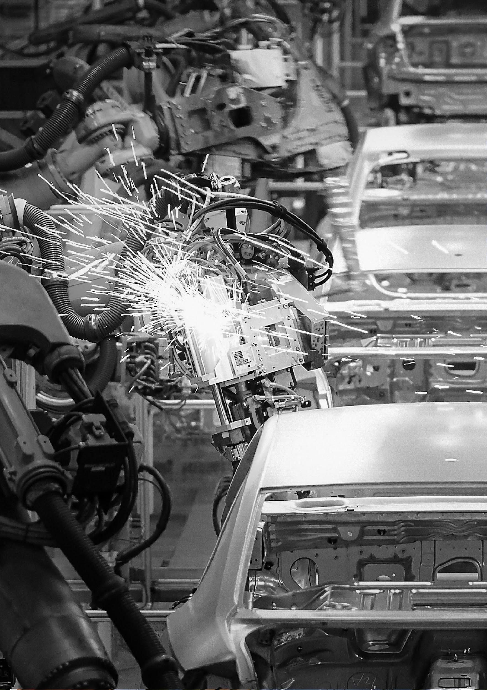

1. Directive 2008/1/EC, https://eur-lex.europa.eu/legal-content/EN/TXT/?uri=CELEX:32008L0001
2. Directive 2001/80/EC, https://eur-lex.europa.eu/legal-content/EN/TXT/?uri=CELEX:32001L0080
3. Directive 2000/76/EC, https://eur-lex.europa.eu/legal-content/EN/TXT/?uri=CELEX%3A32000L0076
4. Directive 1999/13/EC, https://eur-lex.europa.eu/legal-content/EN/TXT/?uri=CELEX:31999L0013
5. https://eur-lex.europa.eu/legal-content/EN/TXT/?uri=CELEX%3A31978L0176
6. https://eur-lex.europa.eu/legal-content/EN/TXT/?uri=CELEX%3A31982L0883
7. https://eur-lex.europa.eu/legal-content/EN/TXT/?uri=CELEX%3A31992L0112